Practical 3.

SQL Queries to filtering data using IN, NOT IN, BETWEEN, NOT BETWEEN, DISTINCT clauses.

***Query1. Write SQL query to create EMP1_2120 Table.***

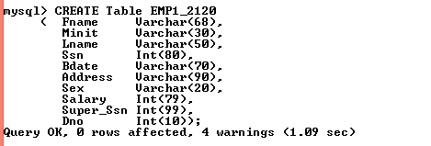

***Query2. Write SQL query to insert records in the EMP1_2120 Table.***

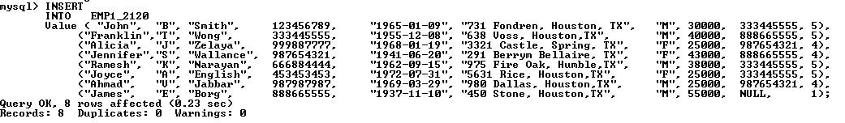

***Query3. Write SQL query to show the records in the EMP1_2120 Table.***

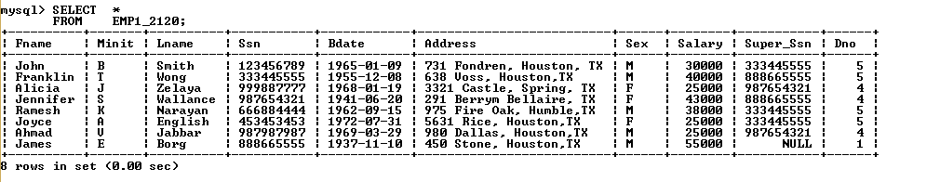

***Query4. Write SQL query to create Department_2120 table.***

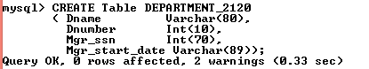

***Query5. Write SQL query to insert records in Department_2120 Table.***

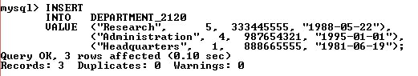

***Query6. Write SQL query to show records in Department_2120 Table.***

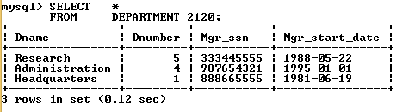

***Query7. Write SQL query to create Dept_location-2120 Table.***

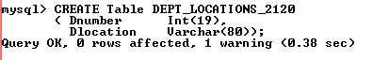

***Query8. Write SQL query to insert records in the Dept_location_2120 Table.***

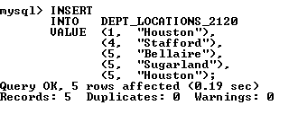

***Query9. Write SQL query to show records in the Dept_location_2120 Table.***

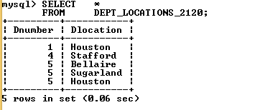

***Query10. Write SQL query to create Project_2120 Table.***

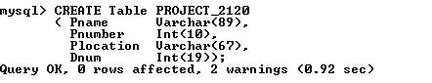

***Query11. Write SQL query to insert records in the Project_2120 Table.***

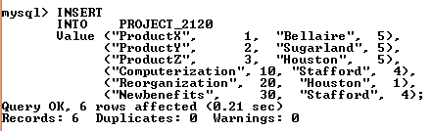

***Query12. Write SQL query to show records in the Project_2120 Table.***

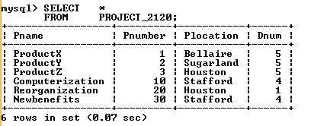

***Query13. Write SQL query to create Works_on_2120 Table.***

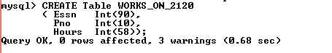

***Query14. Write SQL query to insert records in the Works_on_2120 Table.***

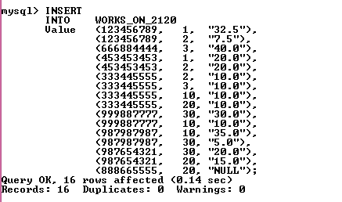

***Query15. Write SQL query to create Dependent_2120 Table.***

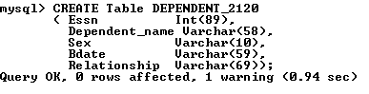

***Query16. Write SQL query to insert records in the Dependent_2120 Table.***

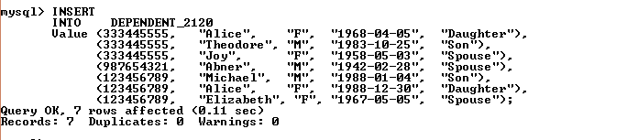

***Query17. Write SQL query to show records in the Works_on_2120 Table.***

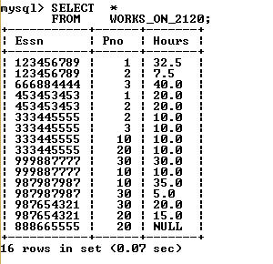

***Query18. Write SQL query to show records in the Dependent_2120 Table.***

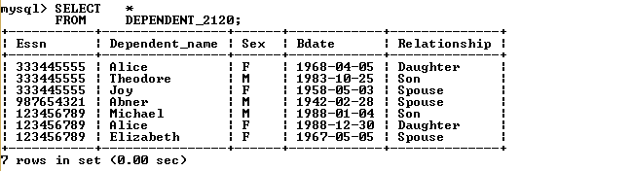

***Query .19 Write SQL query to create EMP2_2120 Table.***

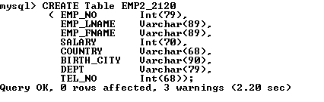

***Query.20 Write SQL query to insert records in the EMP2_2120 Table.***

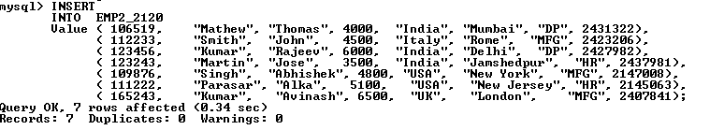

***Query21.Write SQL query to show records in the EMP2_2120 Table.***

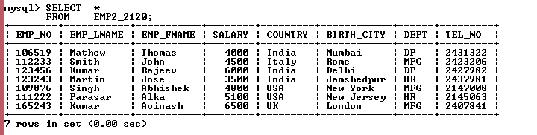

***Query22. Write SQL query to list out Fname, Lname as employee name whose salary, 25000, 43000, 30000.***

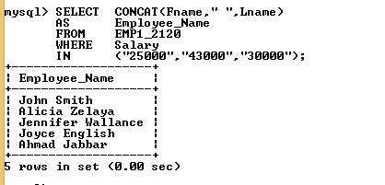

***Query23. Write SQL query to list out dependent name whose relationship status Son and Daughter.***

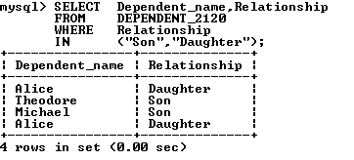

***Query24. Write SQL query to list out Fname, Lname and address of employees having Salary> 26000, and less than 45000.***

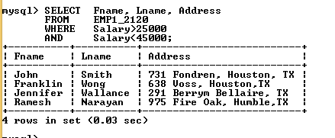

***Query25. Write SQL query to list out the Fname and Lname as Employee name who does not work in the H.R., D.P.***

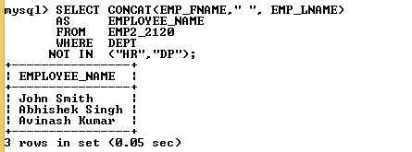

***Query26. Write SQL query to list out Employee no, Salary, Country who has Salary > 4700 and not working in the DP and HR department.***

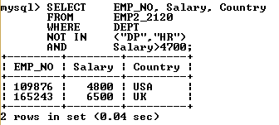

***Query27. Write SQL query to list out employee details working in department MFG, HR, and Salary > 4900.***

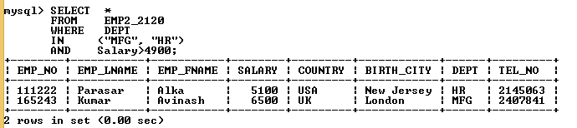

***Query28. Write SQL query to list out name and address of employee who are born form 1960-1970.***

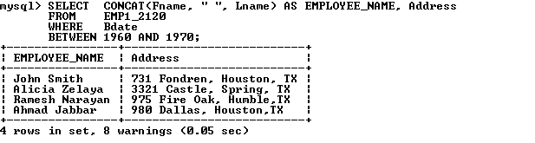***Query29. Write SQL query to list out Country of employee using distinct.***

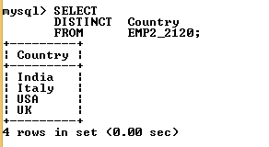

***Query30. Write SQL query to list out EMP_FNAME and Salary Between 4000 and 6000.***

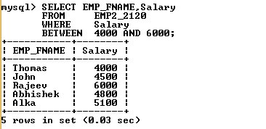

***Query31. Write SQL query to list out employee Fname, Sex, Salary of employee where salary between 26000 and 44000.***

